H.T No
Regulations:
A17

Sreenidhi Institute of Science and Technology
(An Autonomous Institution)
Code No: 6E517 Date: 15-July-2021(FN)

B.Tech III-Year II-Semester Pending External Examination, July-2021 (Supplementary)
THEORY OF COMPUTATION (CSE)

Time: 3 Hours Max.Marks:75

Note: a) No additional answer sheets will be provided.
b) All sub-parts of a question must be answered at one place only, otherwise it will not be valued.
c) Missing data can be assumed suitably.

ANSWER ANY 5 OUT OF 8 QUESTIONS. EACH QUESTION CARRIES 15 MARKS.

Bloom's Cognitive Levels of Learning (BCLL)

Remember | L1 | Apply | L3 | Evaluate | L5
Understand | L2 | Analyze | L4 | Create | L6

 |  |  | BCLL | CO(s) | Marks
1. | a) | State the transition diagram for the NFA that accept the set of strings of 0’s and 1’s such that the 10th symbol from right end is 1. Obtain the equivalent DFA for it. | L2 | CO1 | [8M]
 | b) | State the transition diagram for the DFA with minimal number of states for the following automata. State “a” is the initial state and state “c” is the final state. | L2 | CO1 | [7M]
   | 0 | 1
  a | b | f
  b | g | c
  c | a | c
  d | c | g
  e | h | f
  f | c | g
  g | g | e
  h | g | c
2. | a) | State the transition diagram for Moore Machine to determine the residue mod 3 for any binary string treated as binary integer. Obtain equivalent Mealy Machine for it | L2 | CO2 | [8M]
 | b) | Consider the transition table of a NFA with € moves, where q0 is the initial state and q1 is the final state. Illustrate the construction of the DFA with minimum number of states using Partitioning Method. | L2 | CO2 | [7M]
   | a | b | €
  q₀ | Ф | Ф | q₁
  q₁ | q₁ | q₂ | Ф
  q₂ | Ф | q₃ | Ф
  q₃ | Ф | Ф | q₁
3. | a) | Apply iterative method to obtain equivalent regular expression for the following NFA represented by the transition table given below, where q0 is the initial state and q2 is the final state. The “-” represents that the move is not defined. | L2 | CO3 | [8M]
   | 0 | 1
  q₀ | {q₀, q₁} | {q₀, q₃}
  q₁ | q₂ | -
  q₂ | q₂ | q₂
  q₃ | - | q₂
 | b) | Applying Pumping Lemma, determine that the following languages are not regular:  - L = {a^{P} | P is prime number}  - L = {a^{n}ba^{n} | n≥0} | L3 | CO3 | [7M]
4. | a) | Construct the context free grammar G generating all integers (with sign, for example +/-). Derive the string -17 and +71 from the CFG. | L3 | CO4 | [8M]
 | b) | Simplify the productions by eliminate the null productions and unit productions from the following productions  S → ABa  A → CD  B → DC  D → dD | €  C → cC | € | L3 | CO4 | [7M]
5. | a) | Design a Turing Machine to accept the language L = {a^{n}b^{n} | n>=1}. Obtain the computation sequence of Turing Machine for processing the input string “aabb”. | L2 | CO5 | [8M]
 | b) | Design a Turing Machine to find the 2’s complement of a given binary number. | L2 | CO5 | [7M]
6. | a) | Determine whether the following lists have a Post Correspondence Solution:  i) M = (abb, aa, aaa) and N = (bba, aaa, aa)  ii) M = (ab, bab, bbaaa) and N = (a, ba, bab) | L3 | CO6 | [8M]
 | b) | Classify the problems into P and NP Problems with examples. | L2 | CO6 | [7M]
7. | a) | Determine DFA with minimum number of states for the set of all strings over {0,1} such that it starts with 0 and has odd length or starts with 1 and has even length | L2 | CO1 | [5M]
 | b) | Construct the transition diagram for DFA with minimal number of states for the following transition diagram.  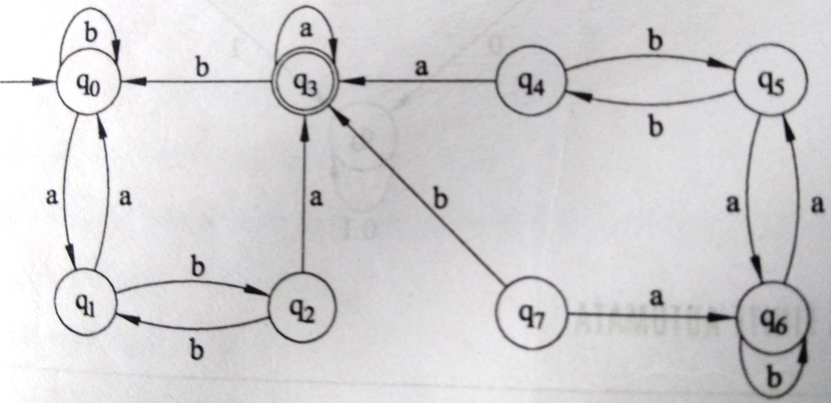 | L2 | CO2 | [5M]
 | c) | Construct right-linear and left-linear grammar for the regular expression  0*(1(0+1))* | L2 | CO3 | [5M]
8. | a) | Construct the Pushdown Automata that accepts the language generated by the following Context Free Grammar:  S → SS | (S) | ( ) | L2 | CO4 | [5M]
 | b) | Design the Turing Machine that recognizes the binary palindromes. | L2 | CO5 | [5M]
 | c) | Define the following:  i. Multi-tape Turing Machine  ii. Universal Turing Machine | L1 | CO6 | [5M]

-- 00 -- 00 –

